Server Web Server with Other Services
Question 1
Install Apache Web Server and PHP on your Linux machine, then create an index.php file that displays "Welcome to My Foodie Blog" when accessed via your browser.
Install Apache and PHP
I installed the Apache web server and PHP packages on the Linux server.
Commands Used:
sudo dnf install httpd php -y
sudo systemctl enable httpd
sudo systemctl start httpd
sudo systemctl status httpd
I created an index.php file inside the Apache web root directory.
Commands:
cd /var/www/html
sudo nano index.php
PHP Code:
<?php
echo "<h1>Welcome to My Foodie Blog</h1>";
?>
I accessed the page using:
http://localhost/index.php
Result
The Apache web server successfully served the PHP page displaying "Welcome to My Foodie Blog".
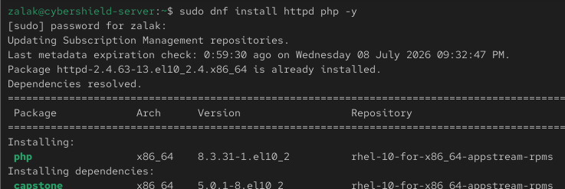

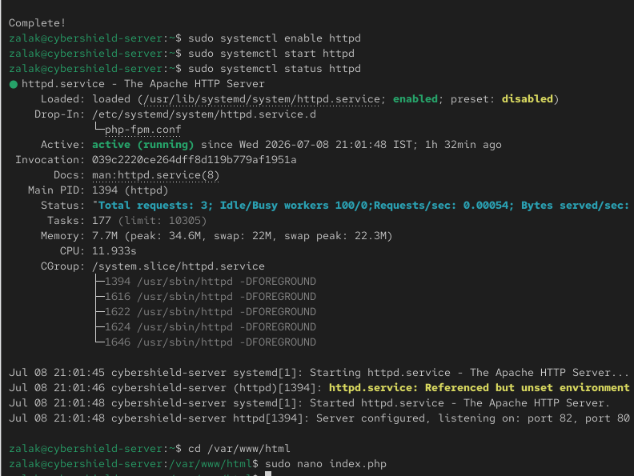

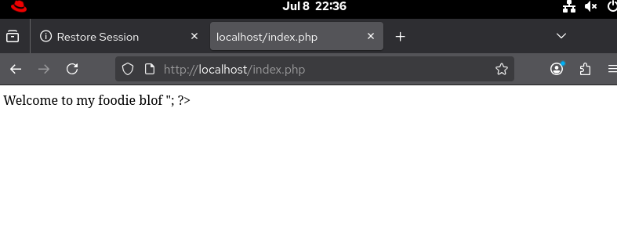
2.Configure your Apache server to serve a custom 404 error page that displays a Zomato-style message: 'Oops! This page is as empty as your cart.'
Configure a Custom 404 Error Page
I created a custom HTML page to display a user-friendly 404 error message and configured Apache to use it.
Commands Used:
cd /var/www/html
sudo nano 404.html
HTML Content:
<!DOCTYPE html>
<html>
<head>
<title>404 Not Found</title>
</head>
<body>
<h1>Oops! This page is as empty as your cart.</h1>
</body>
</html>
I updated the Apache configuration by adding:
ErrorDocument 404 /404.html
Then I restarted the Apache service:
sudo systemctl restart httpd
I verified the configuration by opening a non-existent URL in the browser.
Result:
Apache displayed the custom 404 error page with the message:
"Oops! This page is as empty as your cart."
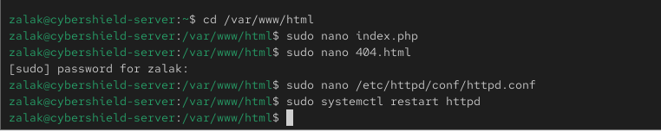

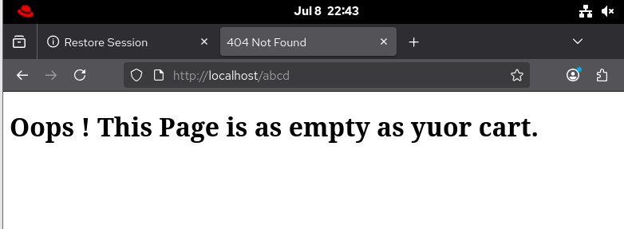
3.Set up a simple FTP server (vsftpd or any other) on your Linux system and upload a sample image file to your web server's root directory using an FTP client.
Configure an FTP Server
I installed and configured the VSFTPD FTP server on the Linux system.
Commands Used:
sudo dnf install vsftpd -y
sudo systemctl enable --now vsftpd
sudo systemctl status vsftpd
I allowed the FTP service through the firewall:
sudo firewall-cmd --permanent --add-service=ftp
sudo firewall-cmd --reload
Using an FTP client, I uploaded a sample image file to the Apache web server root directory (/var/www/html).
I verified the upload by listing the files in the web root directory and opening the image in a web browser.
Commands Used:
ls -l /var/www/html
Step 3: Connect Using the Linux FTP Client
I connected to the local FTP server using the built-in Linux FTP client.
Commands Used:
ftp localhost
I logged in using my Linux username and password and uploaded a sample image file to the web server directory.
FTP Commands Used:
cd /var/www/html
put food.jpg
bye
Step 4: Verify the Upload
I verified that the image was successfully uploaded to the web server directory.
Command Used:
ls -l /var/www/html
I then accessed the uploaded image through the web browser.
URL:
http://localhost/food.jpg
Result
The VSFTPD server was successfully configured. The sample image was uploaded using the Linux FTP client and was successfully accessible from the Apache web server.
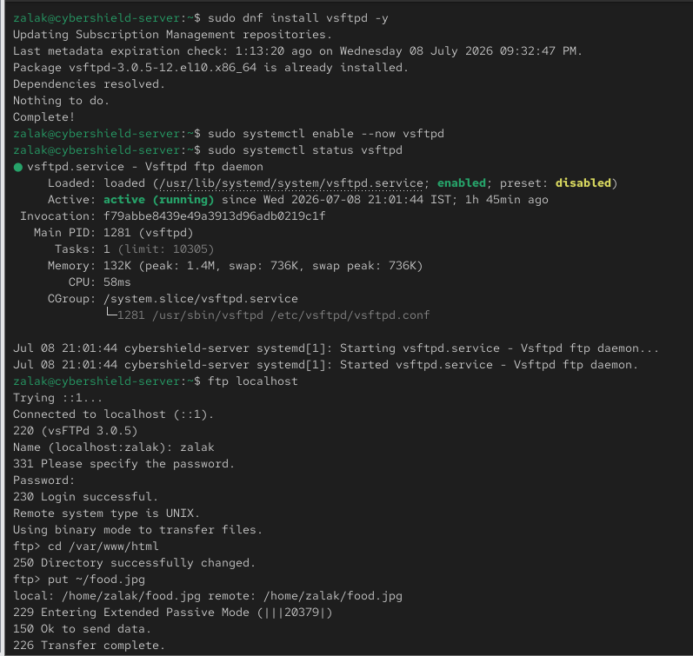
4.Configure your web server to also run a basic Node.js service on a different port (e.g., 3000) that returns JSON data for a mock 'Now Playing' playlist, similar to Spotify. Test accessing both the PHP web page and the Node.js playlist endpoint from your browser.
Configure a Basic Node.js Service
I verified that Node.js was installed and created a simple Node.js application that listens on port 3000 and returns JSON data for a mock "Now Playing" playlist.
Commands Used:
node -v
npm -v
mkdir ~/music_api
cd ~/music_api
nano app.js
node app.js
Verification:
curl http://localhost:3000
Result:
The Node.js service started successfully on port 3000 and returned JSON data. The Apache web server continued serving the PHP application independently on port 80, demonstrating that both services were running simultaneously.
